**MONGO DB**

A Microsoft excel is a Database Management System but it is not a relational DBMS.

A relational database used the notion of databases separated int tables where each column represents a

field and each row represents a record.

Tables can be related with the help of foreign keys.

LIMITATIONS OF RELATIONAL DATABASES:

MongoDB is an open-source database that uses a document-oriented data model and a non

structured query language.

Being a **NoSQL tool** means that it does not use the usual rows and columns that you so much

associate with the relational database management. It is an architecture that is built on

collections and documents. The basic unit of data in this database consists of a set of key–value

pairs.It allows documents to have different fields and structures. This database uses a

document storage format called BSON which is a binary style of [JSON](https://intellipaat.com/blog/processing-json-data-in-real-time-streaming-using-storm-kafka/) documents.The data

model that MongoDB follows is a highly elastic one that lets you combine and store data of

multivariate types without having to compromise on the powerful indexing options, data access,

and validation rules. There is no downtime when you want to dynamically modify the schemas.

What it means that you can concentrate more on making your data work harder rather than

spending more time on preparing the data for the database.

<https://www.youtube.com/watch?v=P5JykHIOOec>

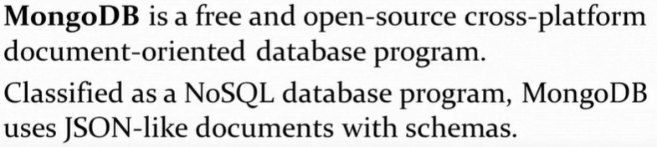

Cross platform as it can be used in any platform

Document Oriented DB since it Stores data in form of Json or XML format.

BSON- Binary JSON

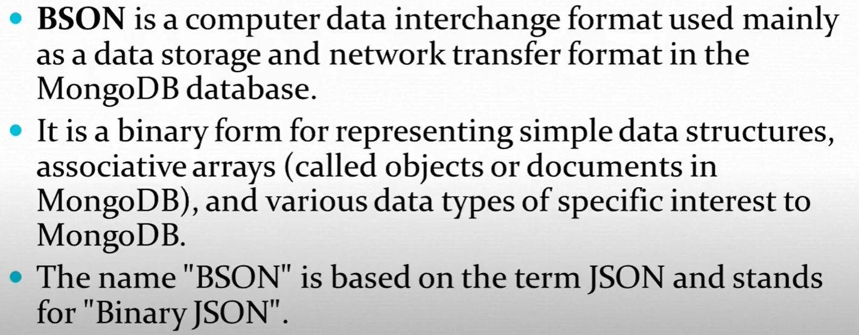

It stores data in BSON format.

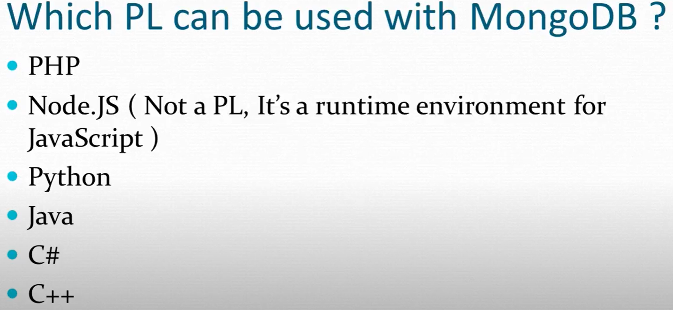

Softwares:

MongoDB community Server

RoboMongo (GUI for MongoDB) New name is Robo 3T

Establish connection for MongoDB:

1. Open cmd and type—> mongod
2. Open new cmd and enter mongo and the connection it established

OR

1. Open cmd and type—> mongod
2. Open Robo Mongo and establish the connection

Show dbs --- > Will display all the DBs

Create a new database first --- > use <databaseName> ex: use my_database

To create a connection in the Database. ‘db’ points to the database my_database since above statement is executed first.

Db.createConnection(“Name_Of_Connection”, { JSON is written here which is optional which points to the properties of the collection })

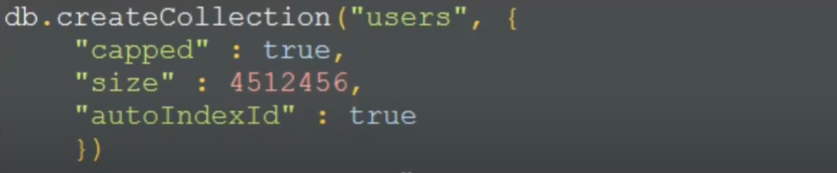

Capped is to set the fixed size tohe collection and hence size is mandatory to use if capped is used

Size: No of bytes of data stored

autoIndexId assigns a default ID to the document. Similar to Id in SQL autogenerate.

Show collections -- > to get all collection list in the DB

To insert into a Collection users--- > db.users.insert(ENTER JSON DATA)

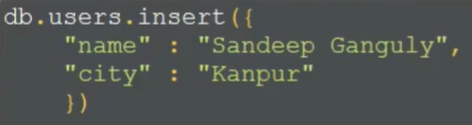

So, here we created a collection and inserted data into it. If we directly use the insert statement without explicitly creating a collection, a default collection with the name is created. But in this scenario, we cannot customize its properties while creation.

To drop/delete a collection ----- > db.users.drop()

To view/check the document ---- > db.users.find()

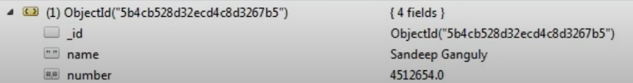

A _id key is created for each document and a default value is assigned to it. This key is unique.

To assign our own value to ID, go by the following method:

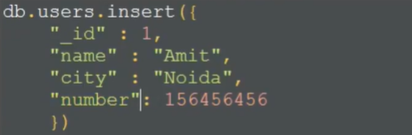

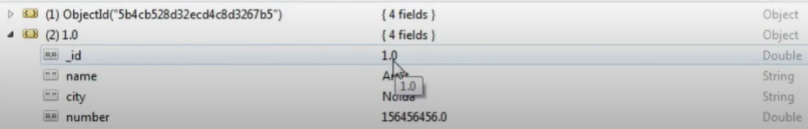

Document type is Object.

To insert multiple documents a t a time, use array of JSONs.

To execute query, press the execute button (**In GREEN**) or press F5.

DATA TYPES in MongoDB:

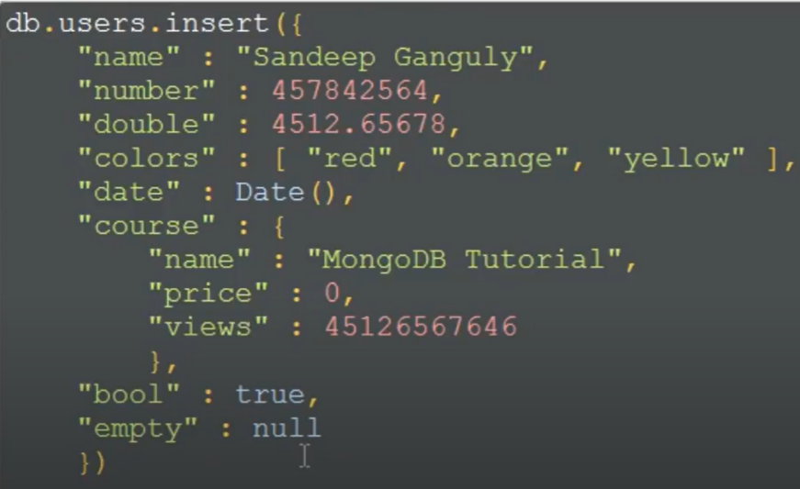

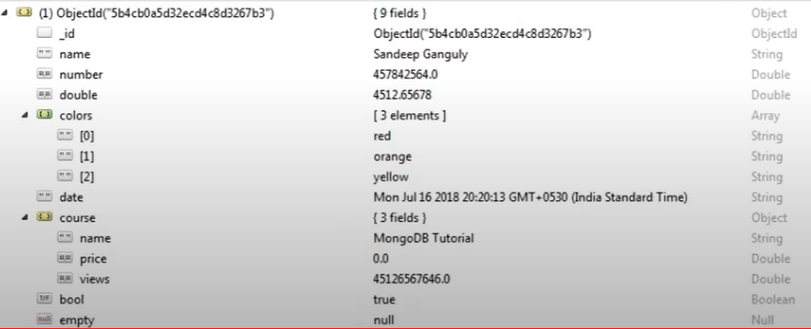

We can read data from collection using find (), But in order to add some condition, we use below:

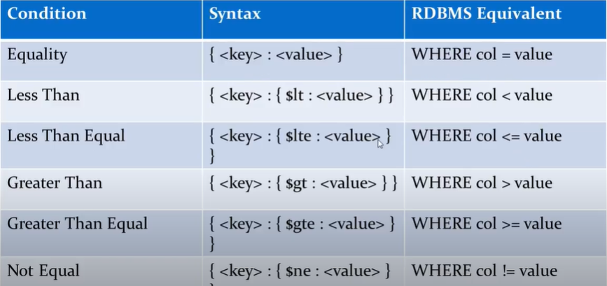

EX: 



It will check if the first key-value is present in any document and then filter the remaining

documents with other key-value pairs (If present).



AND OR operator in MongoDB:



i.e. [ Each key-value pair in curly braces separated by comma]



DELETE DOCUMENT IN COLLECTION:



All documents having this specific key-value gets deleted. If no parameter is given in the remove method, all the documents get deleted. If all documents have same mail ID, all gets deleted.



This will only delete 1 document ( The number passed as second parameter even though all documents have same mail ID.

PROJECTION IN MONGODB: When a find () is executed, details of all the keys gets populated. If we want to have only selected things to display, this is done using projection.



The first {} is used to write conditions like less then or greater than and in the second { }, we write the keys which needs to be displayed. ‘1’ implies yes and ‘0’ implies no. Since, _ID is shown even though it is not added in the list, to hide it we use 0.

To delete a database -- > db.dropDatabase()

INBUILT FUNCTIONS IN MONGO DB:

1. Date ()
2. Limit () ---- > Set a limit on the number of documents
3. Skip () ---- > Skips the specific number of document



If there are total 8 docs, 3rd 4th and 5th is taken.

 ASC = 1 DESC = -1

UPDATE DOCUMENT DATA in MONGODB:

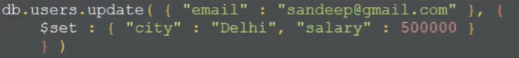

Using { }, it fetched the document which needs to be updated and using data in second { }, it updates the data in that document. If there are multiple documents with same mail ID, all will be updated with the same data, so we use {multi: true} to avoid this.

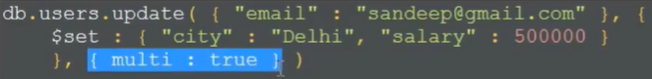

CREATE INDEX IN MONGODB:

If index is created, the search/read operation gets faster in the DB. If index is not created, the MongoDB needs to scan the entire document to search for the keyword or data.

(Similar to index in books which tells us from where the chapter is getting started)



{ } signifies which key to refer for indexing (This key should be present in the documents) and value (1) is for asc, So the indexing will be created on documents arranged in ascending order of their mail IDs.



We can have multiple keys too.

**How to Backup & Restore MongoDB Database**

1. In cmd, run mongod
2. Copy the location of backup folder and open cmd in that folder. Run mongodump

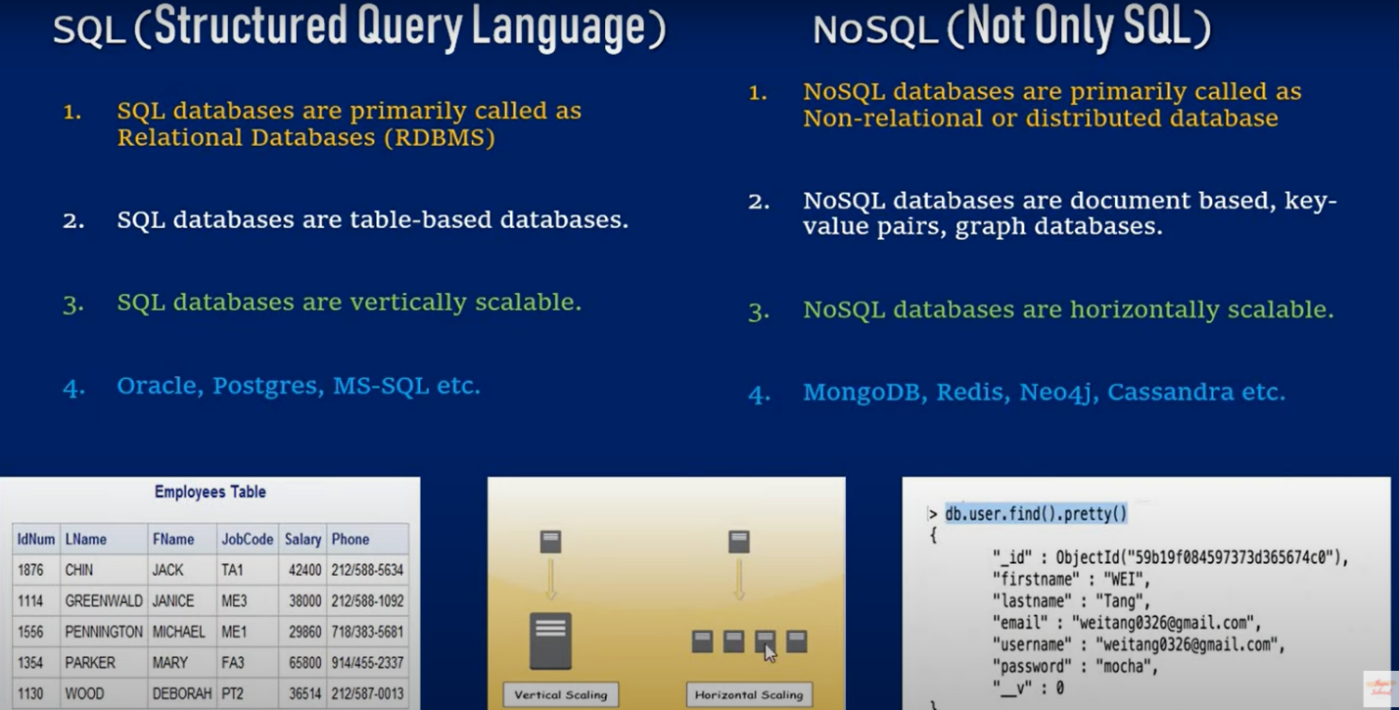

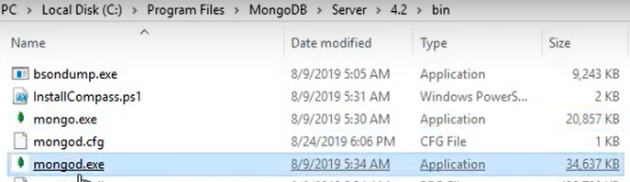

Mongod.exe 🡨--- this is the Database server. We need to start it first and then we can work on mongo using mongo.exe

Or use cmd.. In one cmd run mongod and in other run mongo (an arror will come at end which says it has started)

We have mongo –version to check its version.

When a dataset is created using use dbname, it will not be listed if we use show dbs until the DB has atleast one collection in it.

To check in which DB you are ---- > db

To get all the collections in the DB you are ---- > show collections

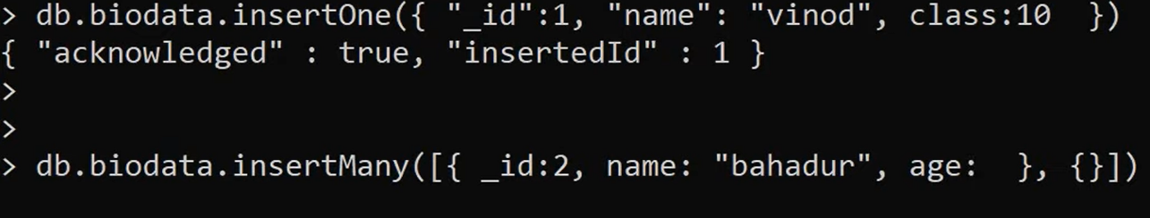

Biodata is collection:: To insert one or multiple documents in a collection.

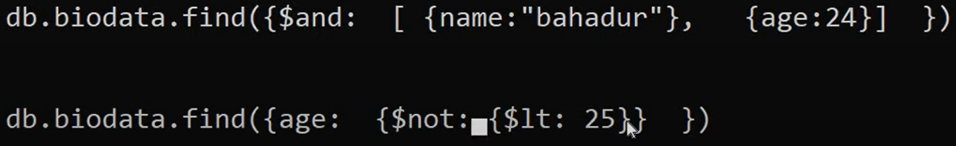

Each Query/condition is written in a curly braces => { }

RELATIONS IN MONGODB: One to One, Many to One, One to Many, Many to Many.

Say we have have one video having multiple comments. So, in RDBMS, we create 2 tables. One having video lists and its PK mapped to other tables having lists of comments.

But In MONGODB, we keep all the comments in that document i.e. create one document inside another.

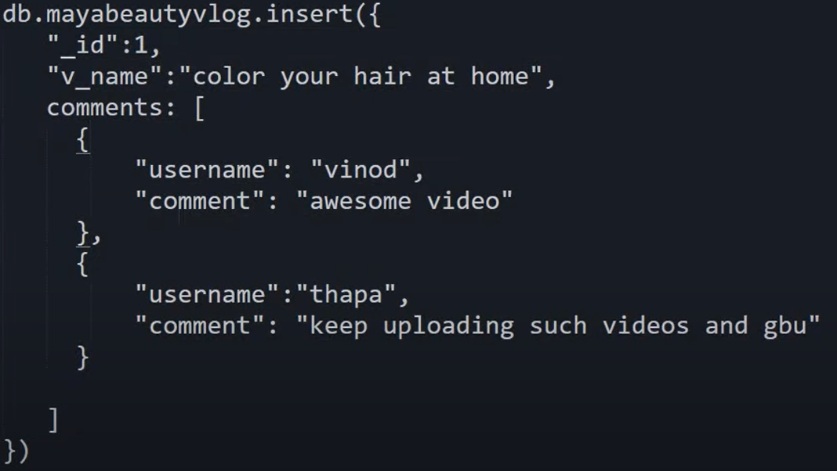

To get just comments of a video:



**AGGREGATION FRAMEWORK:**

Aggregation operations process data records and return computed results. Aggregation operations group values from multiple documents together, and can perform a variety of operations on the grouped data to return a single result. MongoDB provides three ways to perform aggregation: the [aggregation pipeline](https://docs.mongodb.com/manual/aggregation/#aggregation-framework), the [map-reduce function](https://docs.mongodb.com/manual/aggregation/#aggregation-map-reduce), and [single purpose aggregation methods](https://docs.mongodb.com/manual/aggregation/#single-purpose-agg-operations).

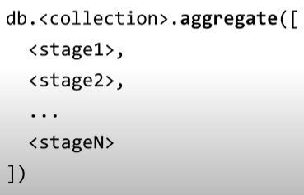

Documents during aggregation pass through the stages. Stage 2 does its operation on the documents sent by stage 1. Each stage is independent of each other.

Aggregation method with empty array will produce the same result as find method with empty query.



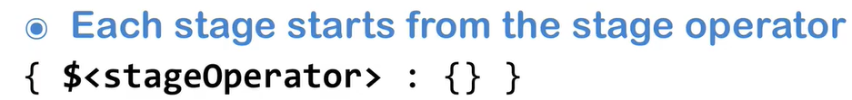

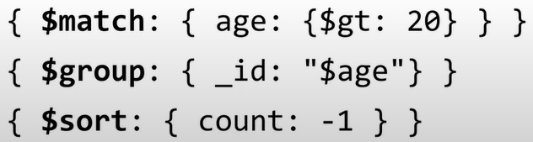

**STAGE OPERATORS USED IN AGGRAGATION:**

**$count, $match, $limit, $group, $project, $sort, $skip, $out** (WRITE RESULT OF AGGREGATION TO ANOTHER COLLECTION)

Aggregation Expressions: Expression refers to the name of the field of the document

Ex: 

Group is a key, so we do not need to use doube quotes.Right side of group key is an object.

**$<value>** inside double quotes “ ”, will be treated as a variable. But in aggregation framework, it is a reference to the field name of the input object

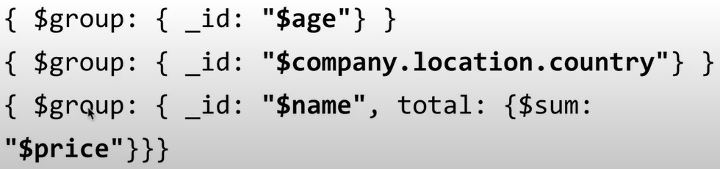

MATCH:  Match specific document using a query.



